Approval of previous minutes/agenda + Messages from Head of Department |  | I | KP | Minutes and agenda was approved  Jan Anker Nielsen and the research groups are working on the budget for expenditure for 2019. Budget for revenues is not final until mid-October. The budget will be presented at our next meeting 24 September.
Follow-up on previous items |  | I | KP
Theme: Career policy  Discussion of Career Policy for MP. Management has come up with the suggestion enclosed on the basic of the University policies. |  |  |  | It was agreed that Management have done a great job with their suggestions for our career policy. However, a few changes should be made and these will be presented at our next meeting
Administrative reorganization  Status on reorganization of administrative reorganization incl:  - joint administration with Math.  - Management of Education (head of Study, Study board etc)  Find enclosed the draft for organization of Administration in MP before decision for Math. | 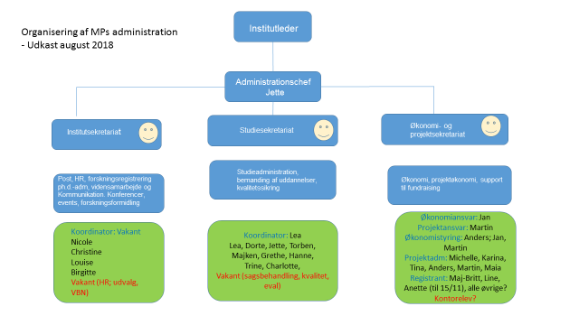 | I | KP | Kjeld Pedersen gave a short introduction to the new administration which will be effectuated as of 1 October and told about the administrative cooperation with Math which will become effective as of 1 January 2019.  There was general statement from the participants at the meeting that the head of study and head of study board should be the same.
Work Place Permits in FIB-LAB  MP-Lab has drafted a proposal for update of the current WPP (Work Place Permits) used at FIB-Lab.  When approved by VIP for use in FIB-Lab it will be part of the safety briefing held this year and it will replace the one currently accessible on our MP web-page for FIB-Lab. There will be no change in responsibilities regarding WPP, it will still be the responsibility of the supervisor that has to verify WPP with a signature. Lab would just like to put more emphasis on instructing the students in how to fill it out and thus include it in the FIB Lab safety briefing.  At a later stage MP-SKJ Labs will discuss if a similar WPP should proposed to VIP-SKJ to be used for SKJ Labs. |  | I | KK | Klaus Kjær presented a draft for a new work Place Permit for LABs at Fib. There were some comments which Klaus will take back to LAB, including:  - Insurance: AAUs insurance for students has to be included  - Who has to sign the form beside the student? Is it always the supervisor or sometimes head of LAB?  - We need a form for Skjernvej and CPH as well
AOB  Working environment (KN) – next meeting  Communication from the management (KN)  Salary |  |  |  | Kjeld Nielsen stated that there is a general lack of information from management regarding changes and any other issues relevant for the employees. A more visible management is also desirable.  Lars Rosgaard Jensen informed the participants of the salary negotiations for VIPs.

